Hadoop Installation

Hadoop Installation Step by Step Procedure

- Prerequisites:

Install Linux 14.04 with jdk8 in VMware Workstation. password : 123 Java 7 (at least)

To install Java 8, run: (Already installed in the machine) //Reference only


sudo add-apt-repository ppa:webupd8team/java sudo apt-get update

sudo apt-get install oracle-java8-installer

sudo apt-get install oracle-java8-set-default

- Start Installation Procedure: Open the terminal in Linux To check installed version.
java -version

sudo apt-get update

- Create hadoop group and new user:

You can add user only in root user. So to change root password and add user


sudo passwd root

(give new password for the root user) // Do remember the password given su root
sudo addgroup hadoop

sudo adduser hduser1

sudo adduser --ingroup hadoop hduser1

sudo adduser hduser1 sudo // for giving sudo rights to hduser1

Provide information you are asked for. (or simply press enter)
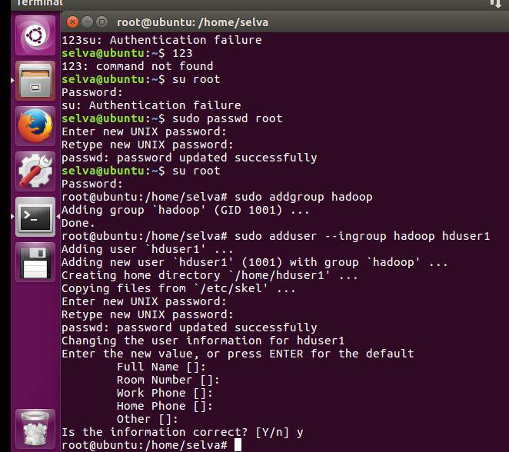

Mr.Anand.L Page 1
Hadoop Installation

- SSH Server To install, run:
sudo apt-get install openssh-server

sudo apt-get update

- SSH key generation

Now go the hduser1 login and check the java version and then Create SSH key and add it to authorized keys:
java -version

ssh-keygen -t rsa -P ""
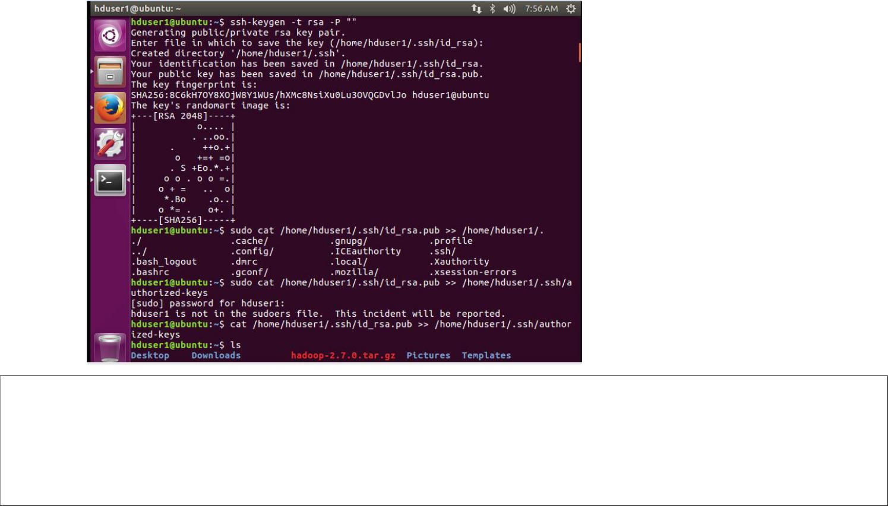

sudo cat /home/hduser1/.ssh/id_rsa.pub >> /home/hduser1/.ssh/authorized_keys sudo chmod 600 /home/hduser1/.ssh/authorized_keys
ssh localhost

exit
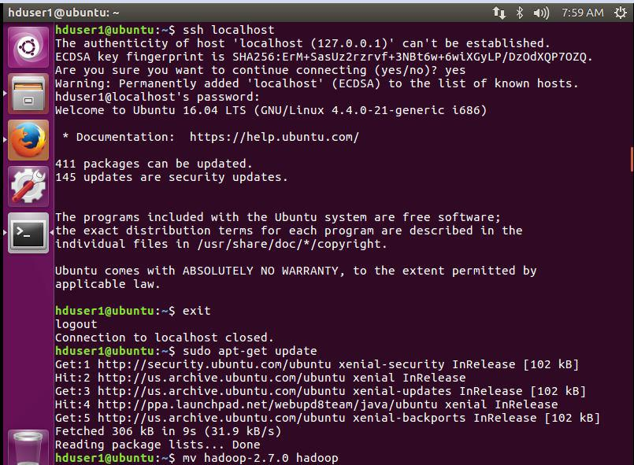

Mr.Anand.L Page 2
Hadoop Installation

- Hadoop Installtion in hduser1 Download and unpack Apache Hadoop 2.7 :
wget http://apache.rediris.es/hadoop/common/hadoop-2.7.0/hadoop-2.7.0.tar.gz sudo tar -xzvf hadoop-2.7.0.tar.gz

sudo mv -R /home/hduser1/hadoop-2.7.0 /home/hduser1/hadoop sudo chown 600 /home/hduser1/hadoop
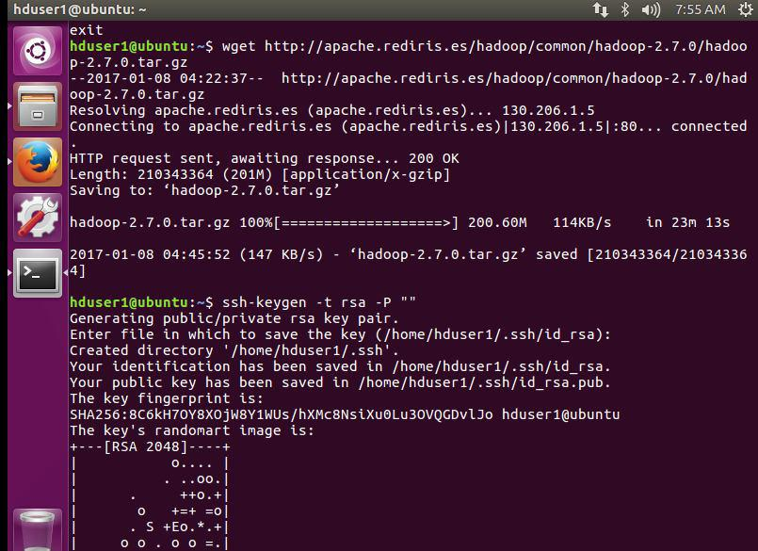

- Hadoop Configuration:

Check where your Java is installed:

readlink -f /usr/bin/java

If you get like this /usr/lib/jvm/java-8-oracle/jre/bin/java, /usr/lib/jvm/java-8-oracle is what you should used for JAVA_HOME.

- Add to ~/.bashrc file: gedit ~/.bashrc
Add the following at the end of the file, save and close it


export JAVA_HOME=/usr/lib/jvm/java-8-oracle

export HADOOP_INSTALL=/home/hduser1/hadoop

export PATH=$PATH:$HADOOP_INSTALL/bin

export PATH=$PATH:$HADOOP_INSTALL/sbin

export HADOOP_MAPRED_HOME=$HADOOP_INSTALL

export HADOOP_COMMON_HOME=$HADOOP_INSTALL

export HADOOP_HDFS_HOME=$HADOOP_INSTALL

export YARN_HOME=$HADOOP_INSTALL

export HADOOP_COMMON_LIB_NATIVE_DIR=$HADOOP_INSTALL/lib/native export HADOOP_OPTS="-Djava.library.path=$HADOOP_INSTALL/lib/native"

Mr.Anand.L Page 3
Hadoop Installation
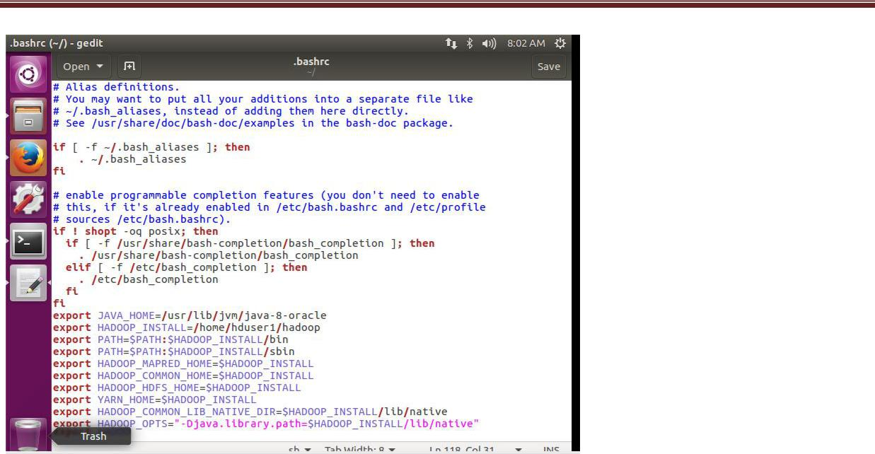

Reload ~/.bashrc file:

source ~/.bashrc

b)Modify JAVA_HOME in /home/hduser1/hadoop/etc/hadoop/hadoop-env.sh:

export JAVA_HOME=/usr/lib/jvm/java-8-oracle

- Modify /home/hduser1/hadoop/etc/hadoop/core-site.xml to have something like: <configuration>
<property>

<name>fs.default.name</name>

<value>hdfs://localhost:9000</value>

</property>

</configuration>

- Modify /home/hduser1/hadoop/etc/hadoop/yarn-site.xmlto have something like: <configuration>
...

<property> <name>yarn.nodemanager.aux-services</name> <value>mapreduce_shuffle</value>

</property>

</configuration>

- Create /home/hduser1/hadoop/etc/hadoop/mapred-site.xml from template:


sudo cp /home/hduser1/hadoop/etc/hadoop/mapred-site.xml.template /home/hduser1/hadoop/etc/hadoop/mapred-site.xml
sudo chmod -R 777 /home/hduser1/hadoop/etc/hadoop/mapred-site.xml

Mr.Anand.L Page 4
Hadoop Installation

- Modify /usr/local/lib/hadoop-2.7.0/etc/hadoop/mapred-site.xml to have something like:

<configuration>

<property>

<name>mapreduce.framework.name</name>

<value>yarn</value>

</property>

</configuration>

g) Modify /home/hduser1/hadoop/etc/hadoop/hdfs-site.xml to have something like:


<configuration>

<property>

<name>dfs.replication</name>

<value>1</value>
</property>

</configuration>

- Format File System hdfs namenode -format
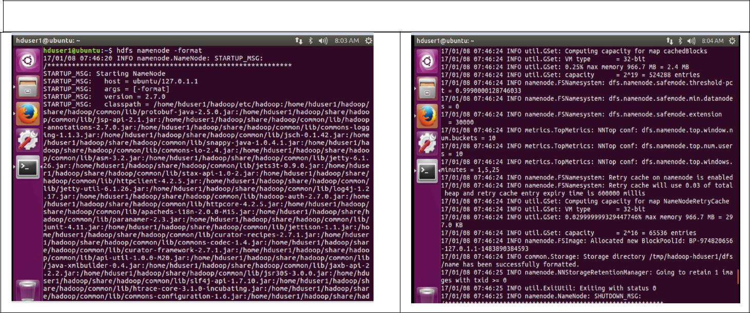

- Start Hadoop:

start-dfs.sh

start-yarn.sh
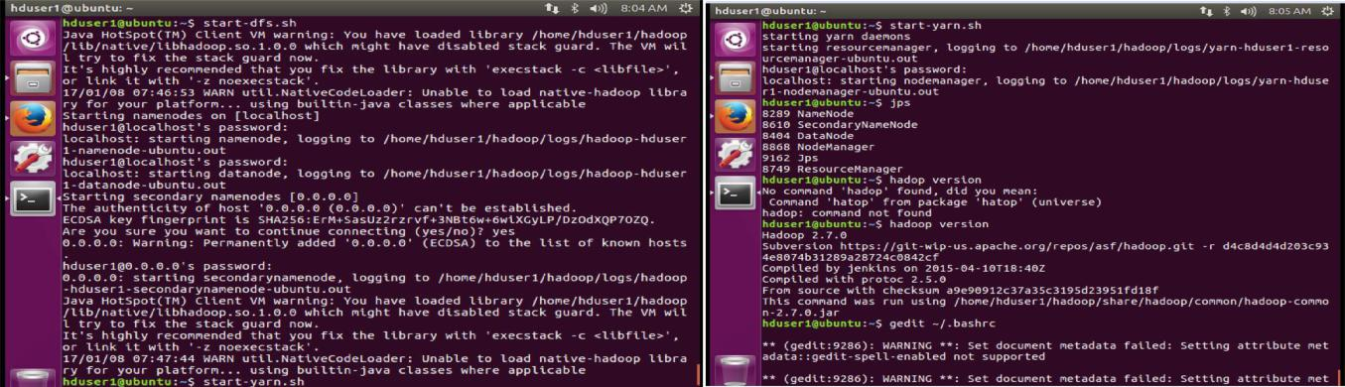

Mr.Anand.L Page 5
Hadoop Installation

- Check if everything is running:

jps

You should get something like: Jps

NodeManager NameNode ResourceManager DataNode SecondaryNameNode


Also you can check the Hadoop through the browser http://127.0.0.1:50070
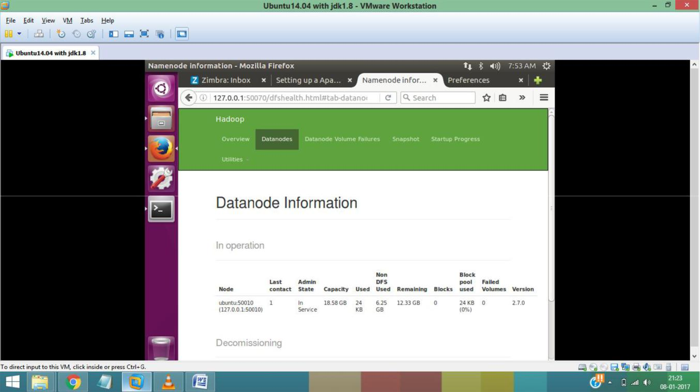

Mr.Anand.L Page 6

